Progress Report 3

Eastern Intitute of Technology ITPM5.240 Agile Projects 2024

Luan Mangels, Alex Bourk, Anthony Nguyen, Hunter Mends

# **Group Contributions and reflection:**

## *Group Reflections:*

Compared to iteration 2, iteration 3 was a lot more scatter-shot and unorganized but we we’re still able to successfully finish everything we needed to complete in terms of our project. However, there was one thing that we couldn’t get done within our time limit and that was the 3rd agenda topic of our meeting report. The hiccup that we had was our group lead (Luan) catching covid near the end of the deadline. This coming out of nowhere caught us off guard and so the rest of us focused on making sure the most important tasks were completed first while putting off any optional ones until we had the time to address them. We still communicated with Luan while he was away to make sure that we stayed on task in terms of our meeting report requirements.

## *Individual contributions:*

Luan Mangels – My biggest contributions to this iteration was once again to be the one to divide tasks, communication handling and to write up the meeting and progress reports. I also had a hand in uploading documents to the GitHub repository and reviewing the tasks my team is completing.

Alex Bourk – Most of my contributions took place on the GitHub repository. These responsibilities included making sure team members uploaded their own respective documents (both for the website and project branches), writing up our “ReadMe” section and finally once again tracking tasks on the GitHub Boards. In addition to this, I was also the main person that wrote up the user acceptance testing document.

Anthony Nguyen – My contribution to iteration 3 consists of keeping the Gantt chart up to date as best I can as well as uploading required files to the GitHub.

Hunter Mends – My contributions to iteration 3 were the creation and completion of the risk register, presenting the register to my team and see if they have any changes they want to add and lastly uploading my part of website and project documents.

# **Evidence of work:**

## *Gantt Chart (Anthony):*

## *Risk Register (Hunter):*

## *GitHub Boards and User acceptance testing (Alex):*

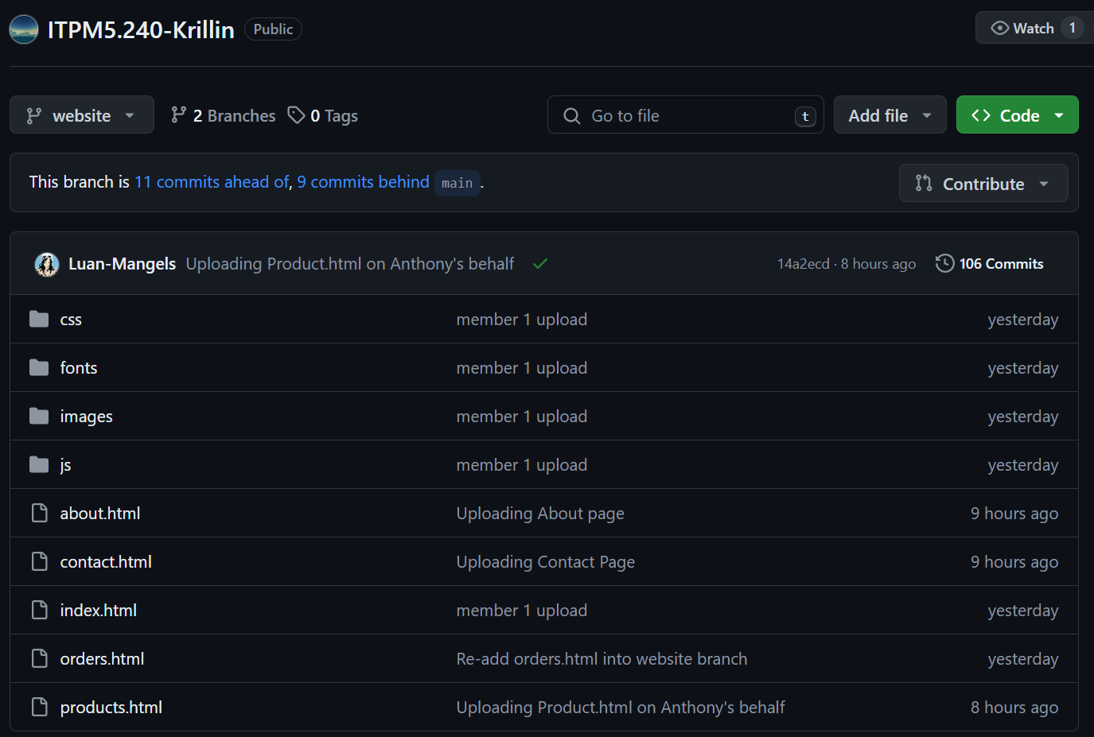

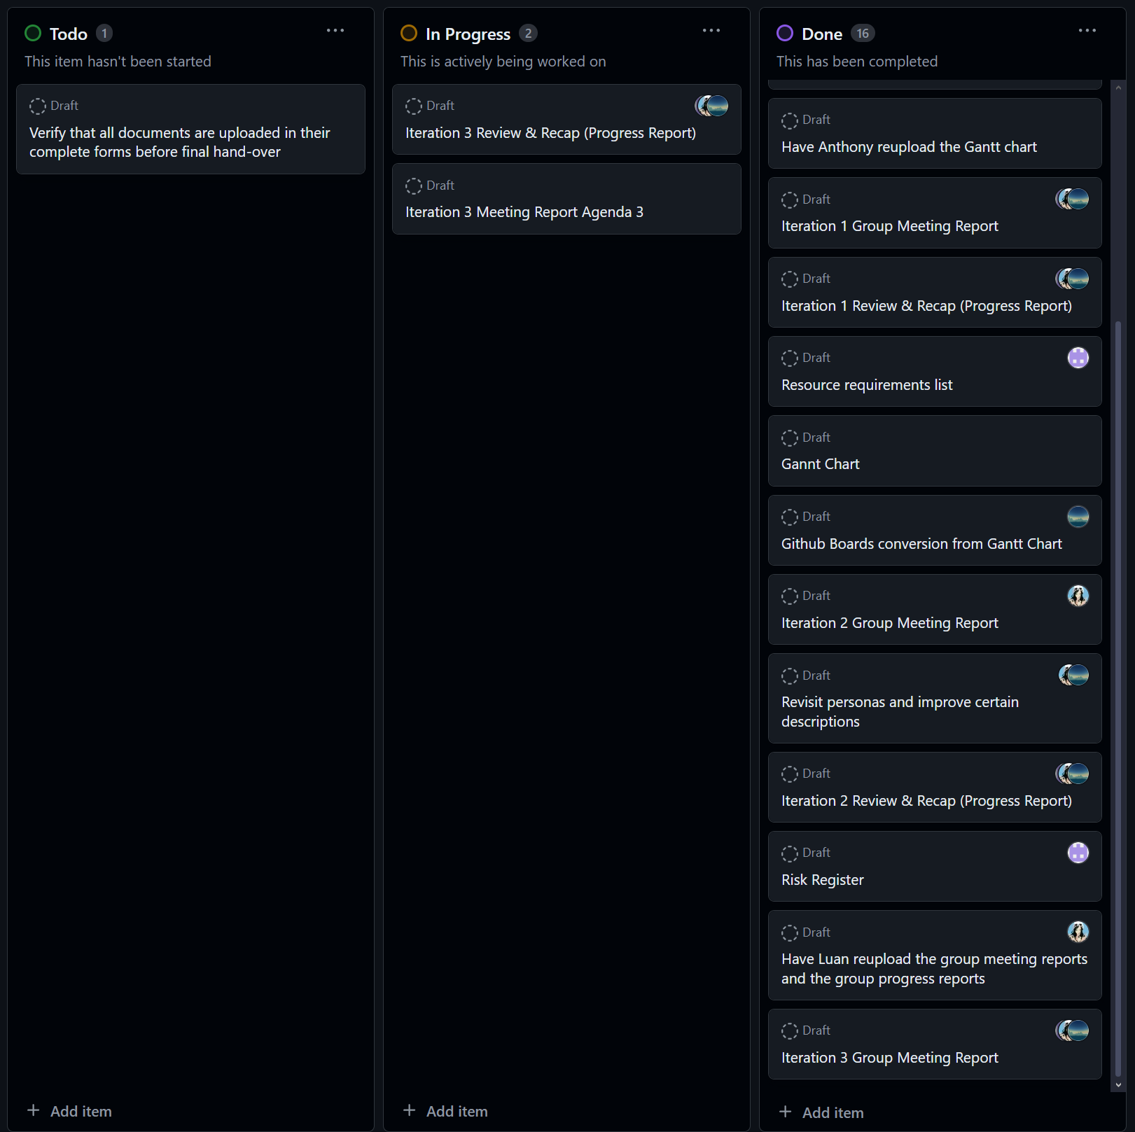

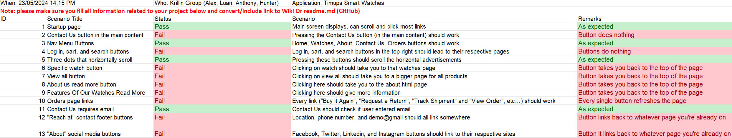

## *Meeting Report (Luan + Group):*



